Deployment

+++++++++++++++++++++++++++++++++++++++++++++++++++++++++++++++++++++++

# repli caset restores pods,deployment restores replicaset, (spin up a pod if pod goes down to keep it up in the desired state, replica set wraps around pod)

#if no pods running we can delete the replica set, if any pod is running deployment will restore the replica set ( pod wraps around containers)

Deploy object wrappes around replica set, deployment provides declarative updates for pods and replica set,you describe a desire state in a deployment file and deployment controller changes actual state to the desired state at a controlled rate.

you can define a deployment to create a new replica set or remove an deployment set and adaopt all the resources you defined.

-=======================================================================

Name Space

In kubernetes, name space provides a mechanism for isolating groups of resources within a single cluster.

## To see all workspace

Kubectl get all –all-namespaces

## Too see the specific name space

Kubectl get svc –n kube-system

## To create a name space

Kubectl create ns kubecart

##create a pod in the different name space ( we can also create a pod with the same name in different name space)

Kubectl run nginx1 –image=nginx –n kubecart

#### YAML file to create a Nginx pod

apiVersion: v1

kind : Pod

metadata:

name: nginx1

namespace: kubekart

spec:

containers:

* name: nginx

image: nginx: 1.14.2

ports:

* containerPort: 80

kubectl apply –f pod.yaml

kubectl get pod -n kubecart

PODS

A pod is the basic execution unit in kubernetes application – the smallest and the simplest unit in the Kubernetes object model that you create and deploy. A pod represents processes running on the cluster.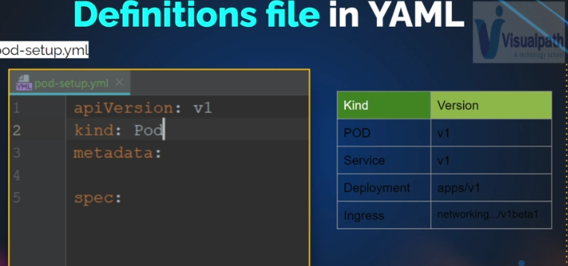

Pods that run a single container:

* The one-container-per pod model is the most common Kubernetes us cases
* Pod as a wrapper around a single container.
* Kubernetes manages the pods rather than the containers directly.

Multi container pod:

* Tightly coupled and need to share resources
* One main container and other as a sidecar or init container
* Each pod is meant to run a single instance of a given application
* Should use multiple pods to scale horizontally.

Pod –setup.yml

apiVersion: v1

kind: Pod

metadata:

name: webapp-pod

labels:

app: frontend

project: infinity

spec:

containers:

* name: httpd-container

image: httpd

ports:

- name: http-port

containerPort: 80

kubectl create –f pod-setup.yml

kubectl get pod

kubectl describe webapp-po

### To get and edit the pod

Kubectl edit pod webapp-pod

Kubectl get pod webapp-pod –o yaml >> webpod-definition.yaml

Kubectl pod –o wide

Kubectl pod web2

Kubectl delete pod web2

Kubectl run web2 –image=nginx

Services

Way to expose an application running on a set of Pods as a network service

Kubernetes Pods are mortal, They are born and when they die, they are not resurrected, if you use a \deployment to run your app, it can create and destroy pods dynamically.

Each pod gets its own IP address, however in a Deployment the set of Pods running in one movement in time could be different from the set of Pods running that application a moment later.

This leads to a problem, if some set of Pods ( call them ‘bacends’) provides functionality to other Pods ( call them ‘frontends’) inside your cluster, how do the frontends find out and keep track of which IP address to connect to, so that the frontend can use the backend part of the workload?

Nodeport

ClusterIP – Internal communication( static endpoint for the application, eg : Tomcat want to communicate with Mysql)

LoadBalancer : Expose to the outside network for production use cases ( I have tomcat server and I want users from the internet to access that)

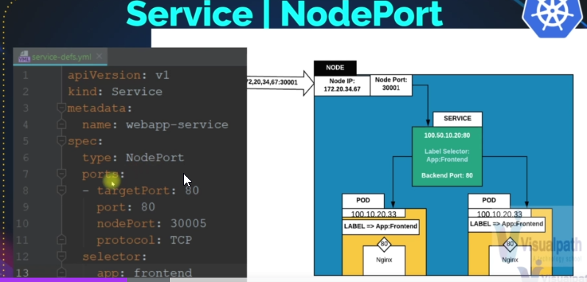

Kubectl create –f service-defs.yaml

Kubectl get svc

Kubectl describe svc webapp-service

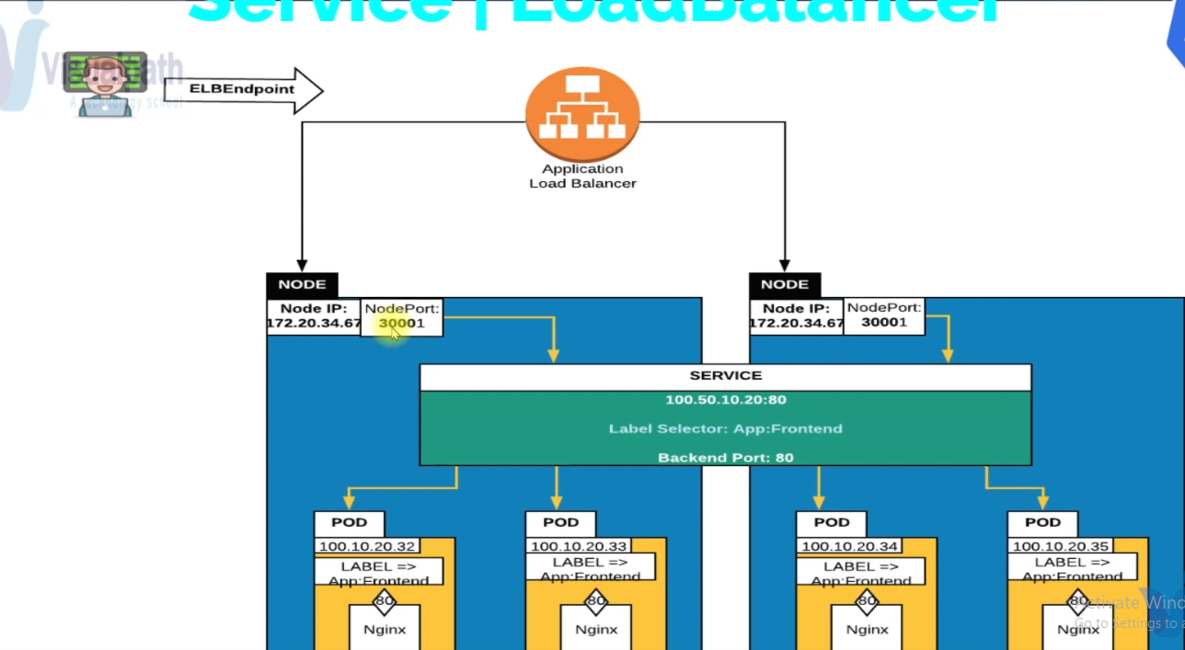

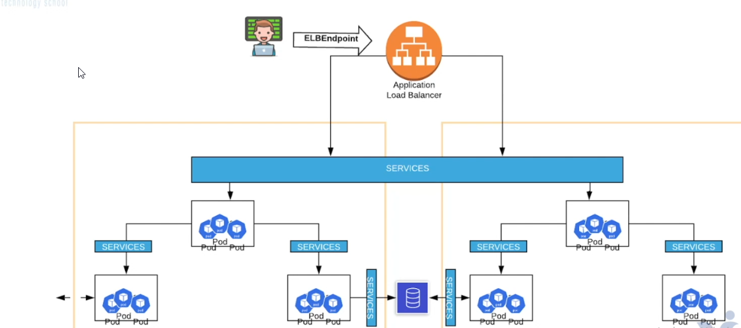

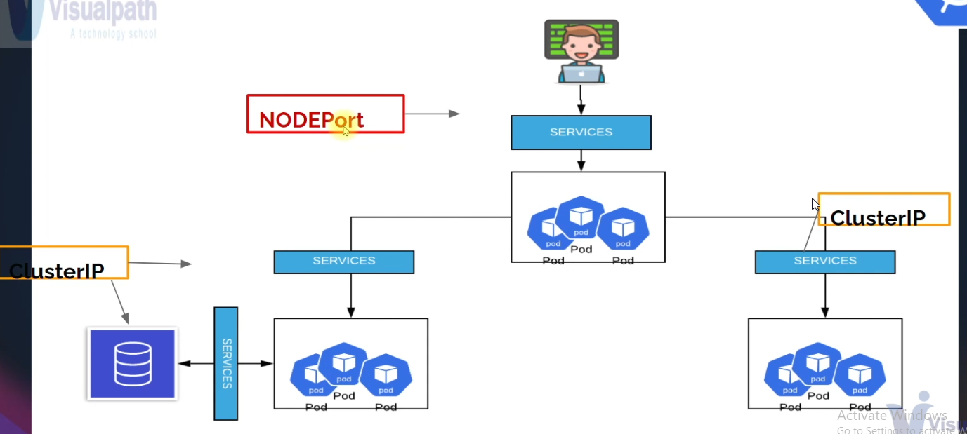

=====================================================================================

**Replication set**

Maintain pods replica

A ReplicaSet's purpose is to maintain a stable set of replica Pods running at any given time. As such, it is often used to guarantee the availability of a specified number of identical Pods.

Imperative way:

Kubectl scale –replicas=1 rs/frontend ( scaling down)

One moreway

Kubectl edit rs frontend

Replicas : 3

In the production always recommended to do in the declarative way.

Deployment

Upgrade, Rollback, changes gracefully

A Deployment controller provides declarative updates for Pods and Replicaset

Define desired state in a Deployment, and the Deployment controller

Changes the actual state to the desired state at a controlled rate.

Deployment creates Replicaset to manage number of pods

Kubectl get sa -A

kubectl get all

kubectl get nodes

kubectl apply -f deployment-with-rolling.yaml

kubectl delete pod nginx

kubectl get rs

kubectl delete rs testdeploy-567ghb7y7

kubectl describe podname

kubectl get deployment

kubectl describe deployment

kubectl get rs --watch

kubectl get pods --all-namespaces -o wide --field-selector spec.nodeName=node1

kubectl get hpa

##In Kubernetes, namespaces provides a mechanism for isolating groups of resources within a single cluster. Names of resources need to be unique within a namespace, but not across namespaces

kubectl get namespace

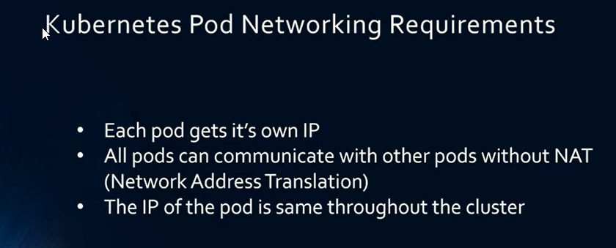

Kubectl get pods –A –o wide

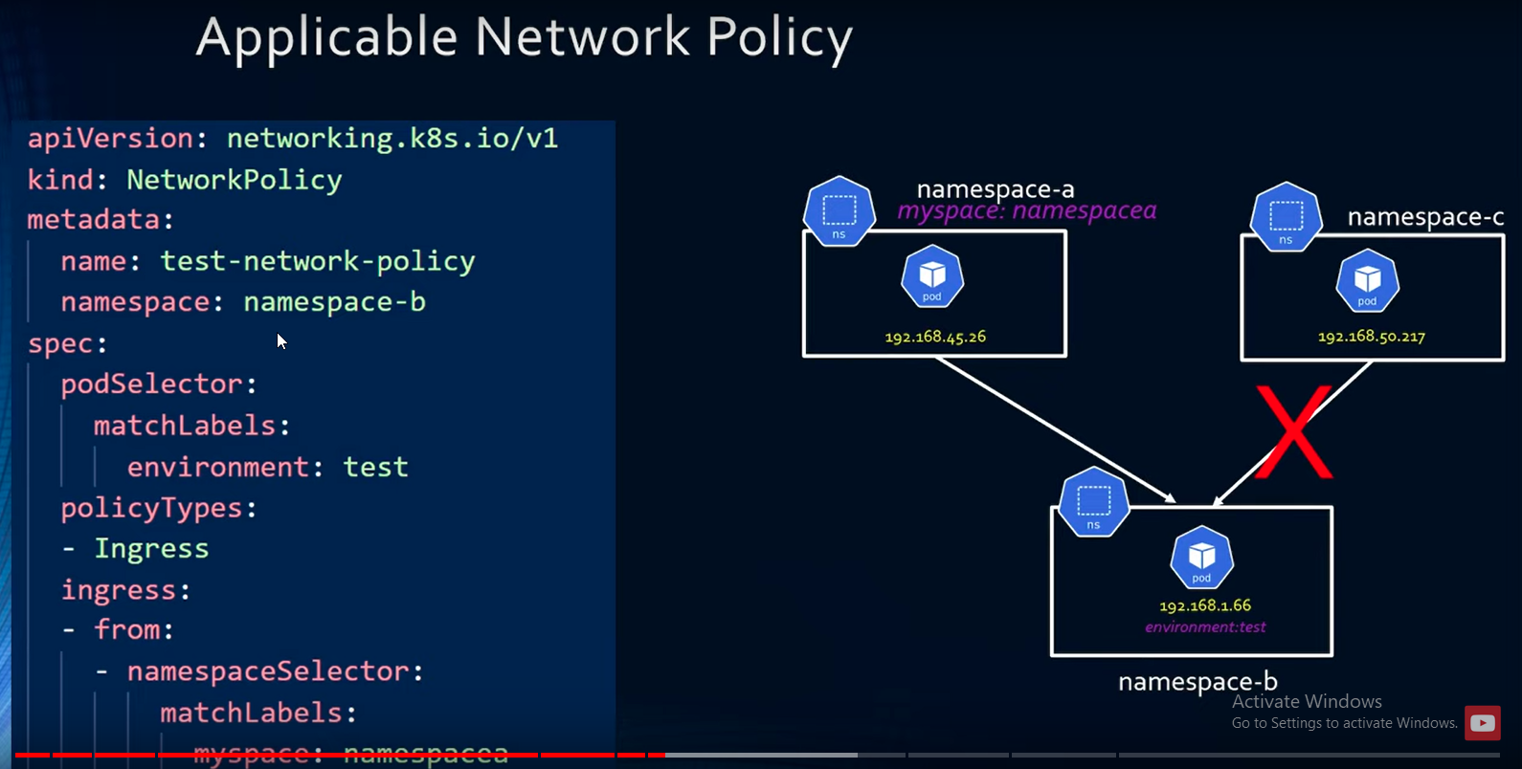





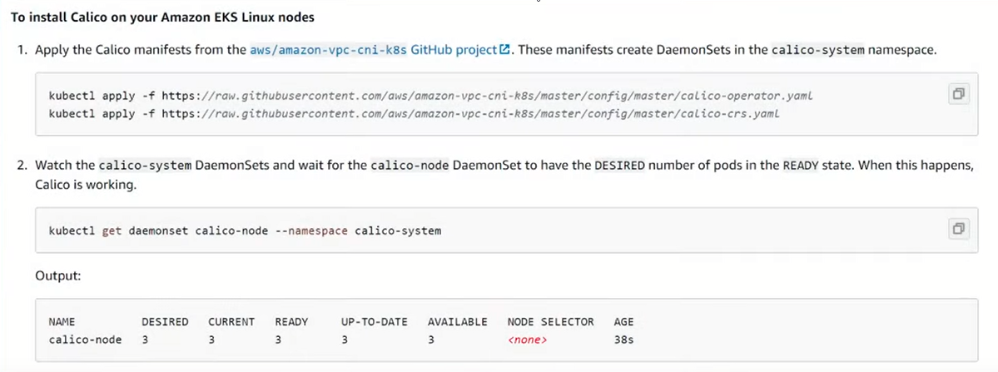

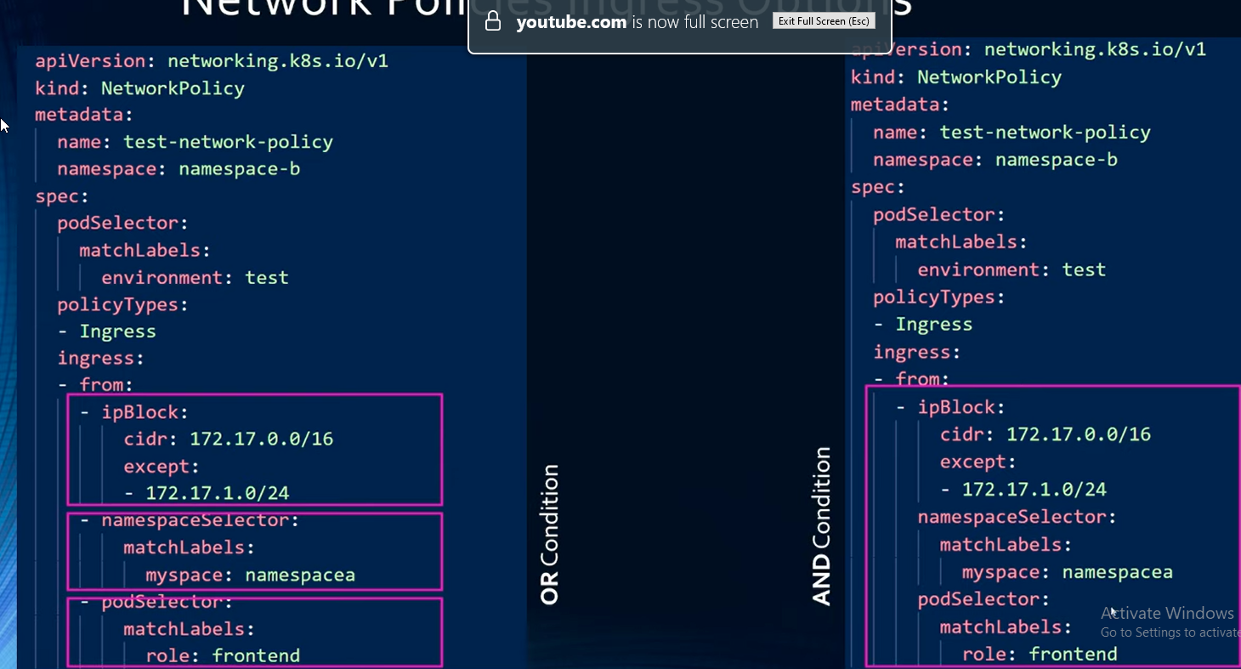

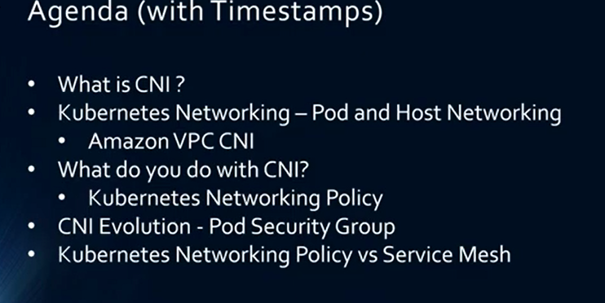

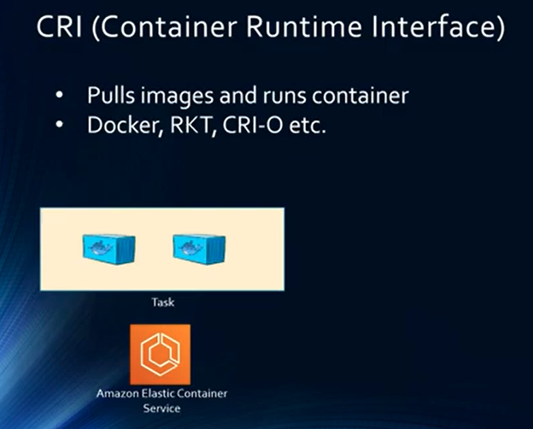

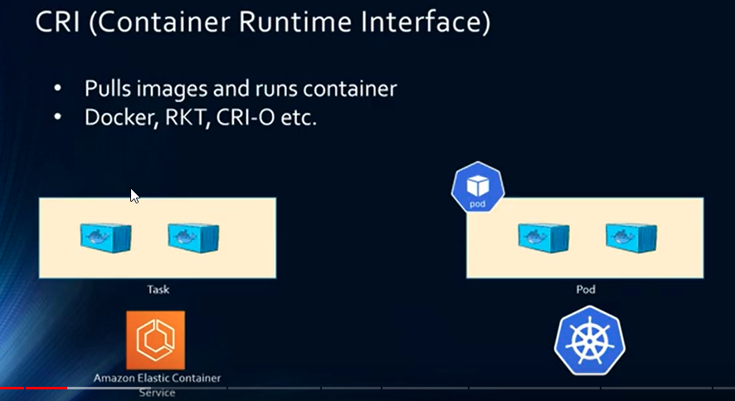

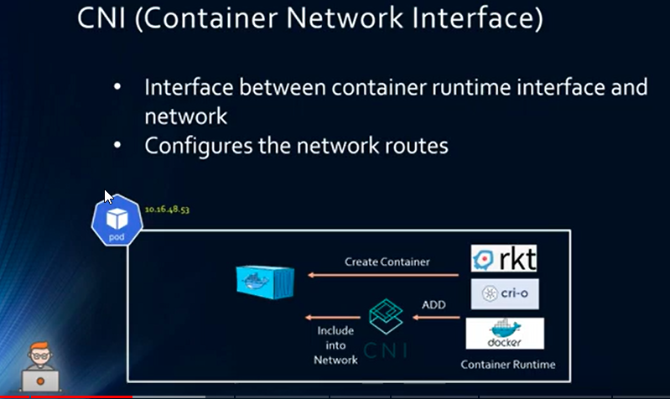

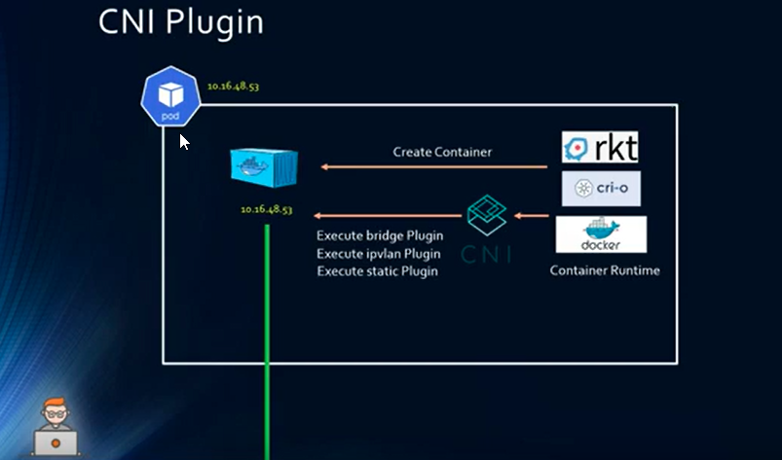

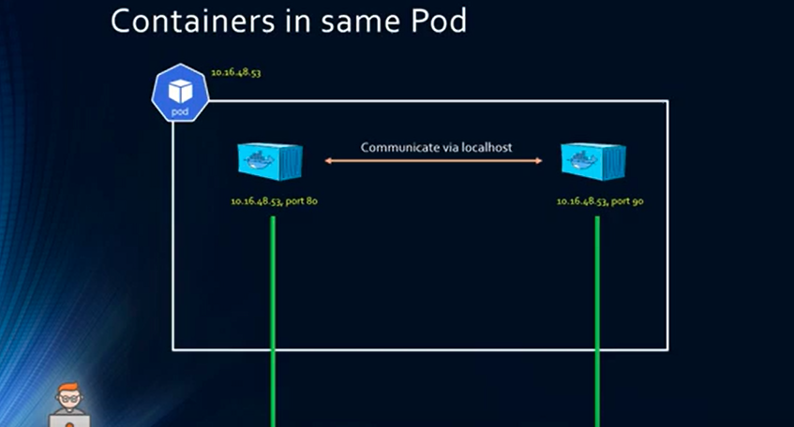

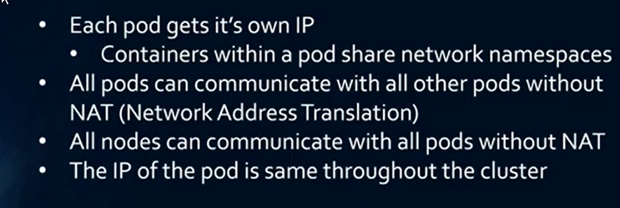

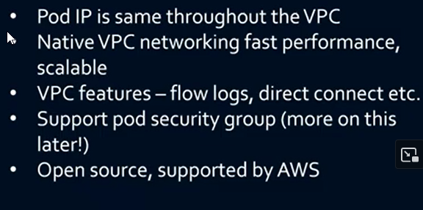

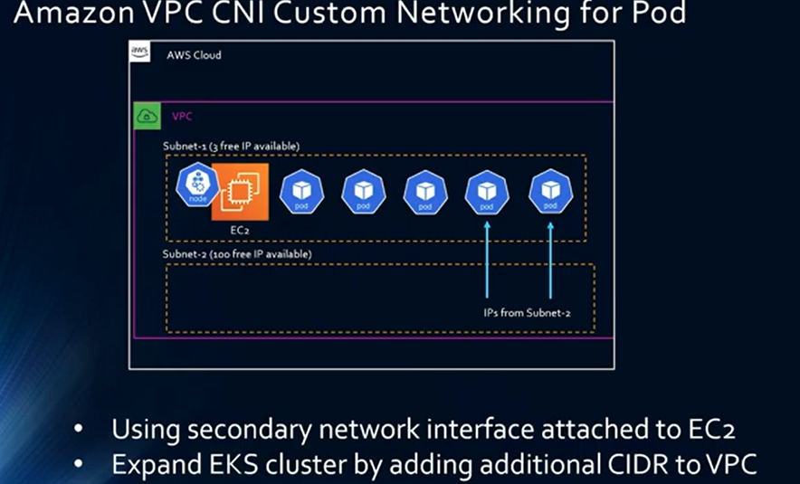

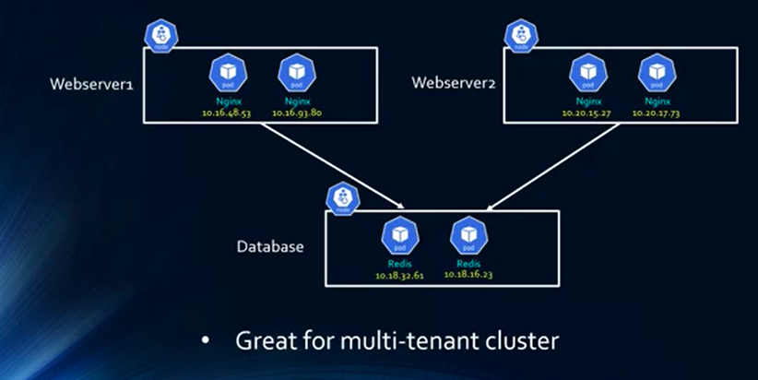

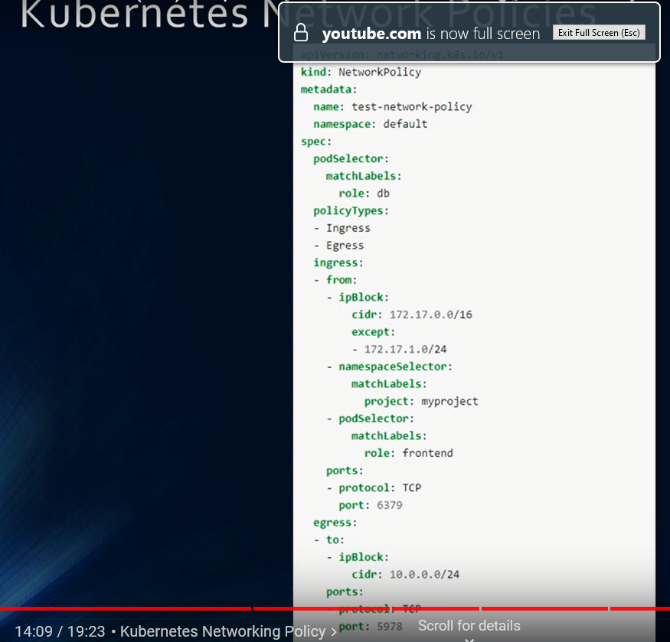

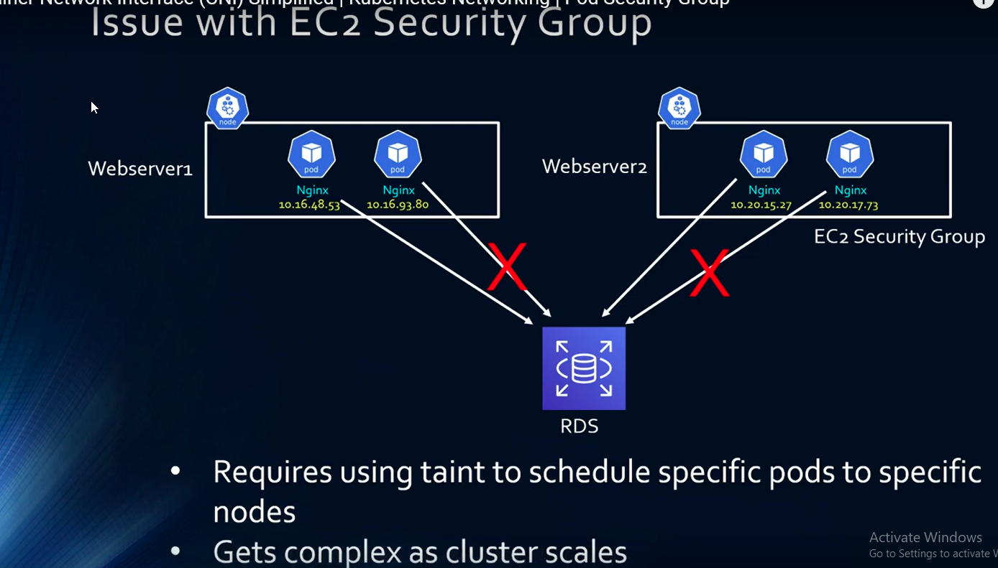

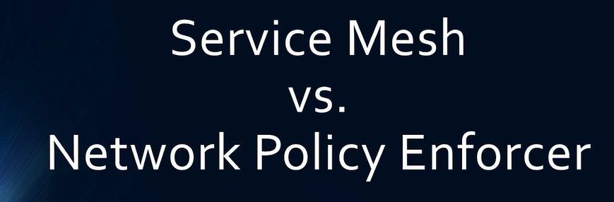

##ping namespace -a TO namespace -b

kubecl -n namespace-a exec test-8455fc-frgj --curl 192.168.1.66

++===========================================================================

EC2 scaling :

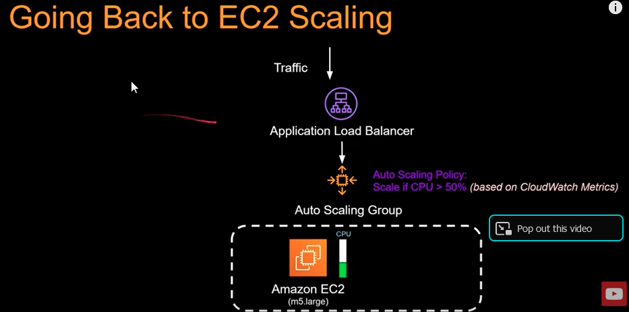

EKS container scaling:

Responsible for scaling pod

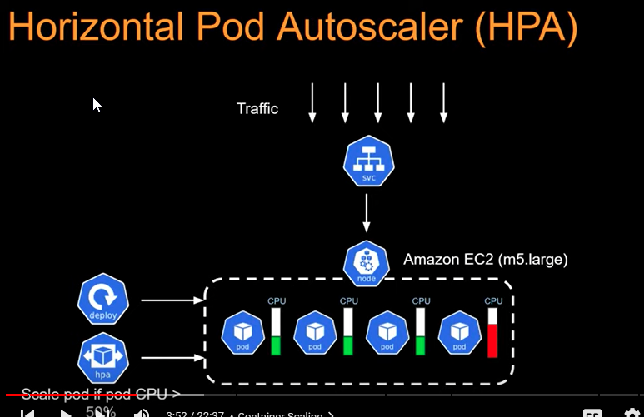

+=================================================================================

EKS Cluster Autos

caler :

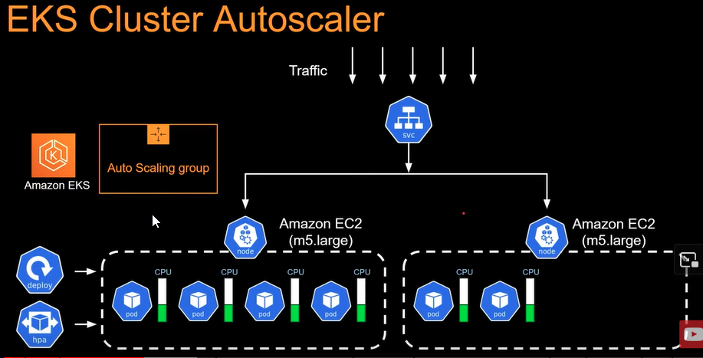

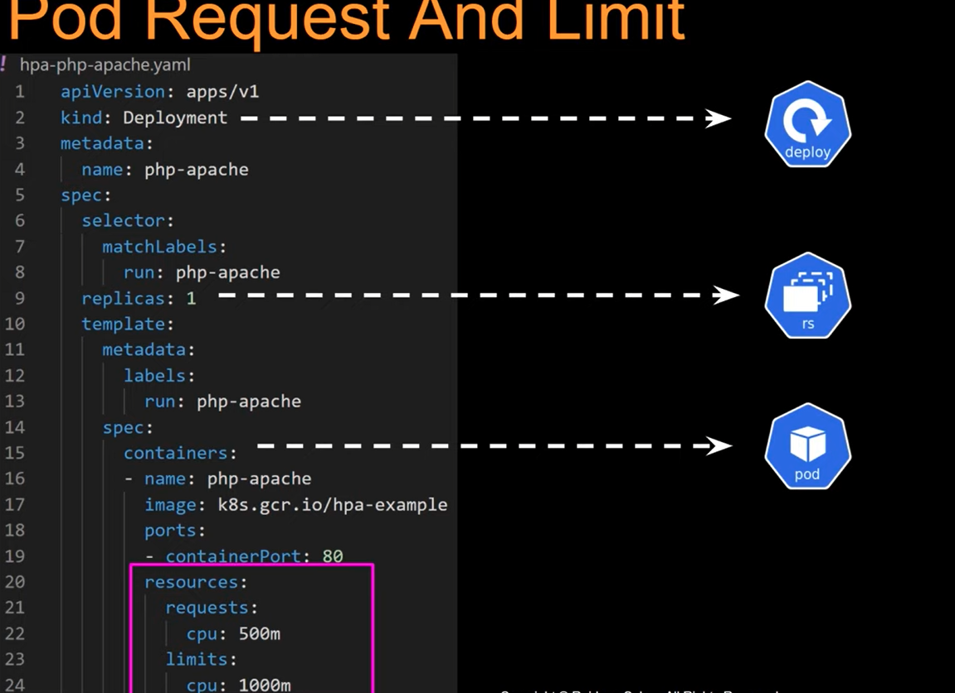

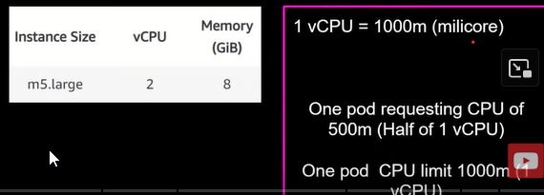

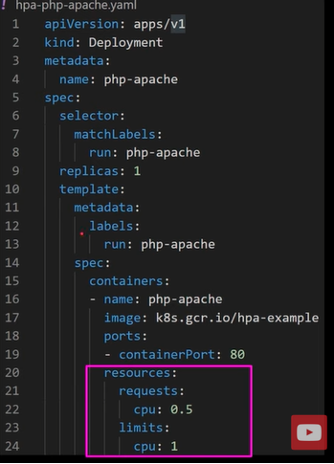

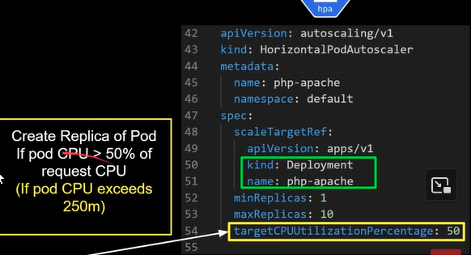

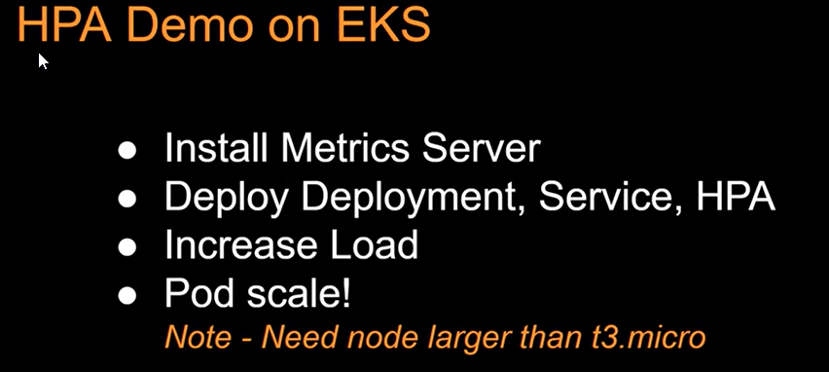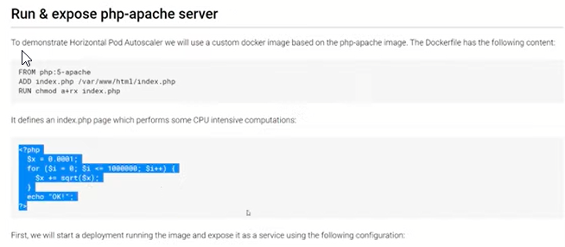

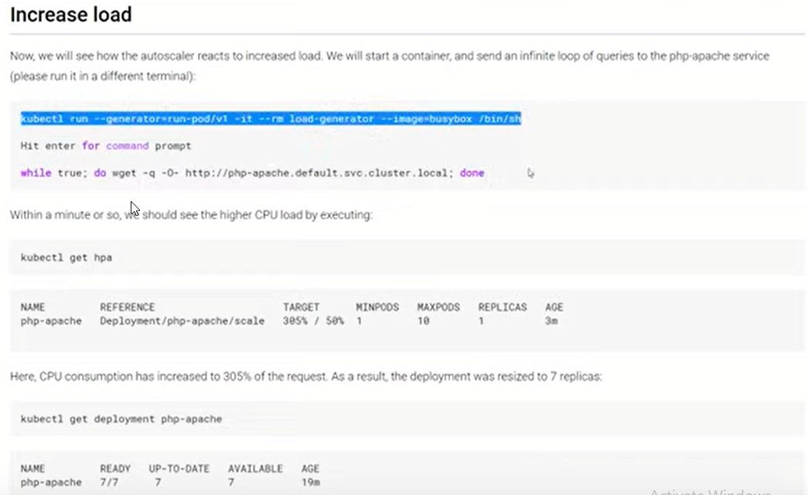

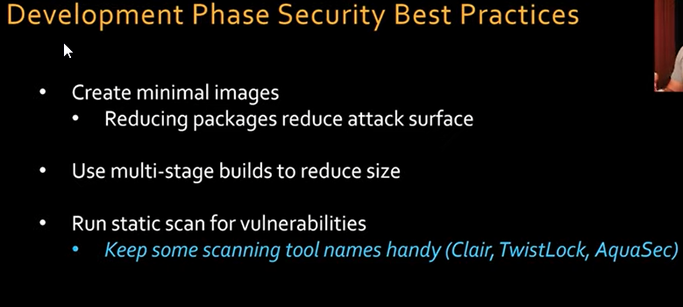

What is clair:

[Clair](https://github.com/quay/clair) is an [open source](https://www.redhat.com/en/topics/open-source/what-is-open-source-software) project which provides a tool to monitor the security of your [containers](https://www.redhat.com/en/topics/containers/whats-a-linux-container) through the static analysis of vulnerabilities in appc and [docker](https://www.redhat.com/en/topics/containers/what-is-docker) containers. Clair is an [API](https://www.redhat.com/en/topics/api/what-are-application-programming-interfaces)-driven analysis engine that inspects containers layer-by-layer for known [security](https://www.redhat.com/en/technologies/guide/it-security) flaws. Using Clair, you can easily build services that provide continuous monitoring for container vulnerabilities.

